

TdRCB User Manual



TdRCB: An open-source software for estimating temperature-dependent receiver code bias variations

Innovation Academy for Precision Measurement Science and Technology,
Chinese Academy of Sciences©

Update: 2026.10

Contents
1 Overview 4
2 TdRCB software 4
2.1 Structure of TdRCB 4
2.2 Processing strategies 5
3 Requirements 7
3.1 Supported platforms 7
3.2 License 7
4 File structure 7
5 Configuration File (config.dat) 8
5.1 Input file configuration 8
5.2 Output file configuration 9
5.3 Processing strategies configuration 10
5.4 Station Information 11
6 Compile and Run 11
6.1 Compile 11
6.1.1 Windows 11
6.1.2 Linux 12
6.2 Run 13
6.2.1 day-by-day process 13
6.2.2 continuous processing 15
6.2.3 Linux Run 17
7 Output file format description 17
7.1 Result File 17
7.2 Process Information File 19
7.3 Log file 20
7.4 tfit File 21
7.5 tres File 21
7.6 Execution Interface 23
Appendix 24
Acknowledgement 27
References 27

1 Overview
Multi-system and Multi-frequency Receiver Code Bias Analysis Software (TdRCB) is an open-source GNSS data processing package specifically designed for extracting time-varying receiver code biases (RCBs). TdRCB is developed in C/C++, which can be easily ported to different operating systems, such as Windows and Linux. It is a post-processing software, which can process multi-frequency data from GPS, Galileo, BDS, GLONASS. Using a least-squares filter (LSF) based on undifferenced and uncombined observations to estimate time-varying RCBs. Furthermore, it requires observation files and broadcast ephemeris, offering a simple operation process. Processing strategies for different data can be configured in the formatted configuration file.

2 TdRCB software

2.1 Structure of TdRCB
Generally, the processing can be summarized into three parts.
（1）Data preparation. The required input files include the observation file and the broadcast ephemeris file. The processing parameters should then be specified in the configuration file. Temperature data are optional.
（2）Data processing. In this step, TDRCB first calculates the satellite information. Cycle slip detection is then performed using the geometry-free combination and the Melbourne-Wübbena combination. After finishing cycle slip detection, the LSF is employed to estimate unknown parameters. Finally, quality control is performed using the DIA method.
（3）Information output. In this step, processing information and estimated parameters, including satellite clock offsets, satellite elevation and azimuth angles, post-fit code and carrier-phase residuals, and time-varying receiver code biases (RCBs), are written to formatted output files. The log file primarily records satellite exclusions during data processing. If temperature data are provided, the software also outputs the fitted model describing the relationship between RCBs and temperature, along with the corresponding fitting residuals.
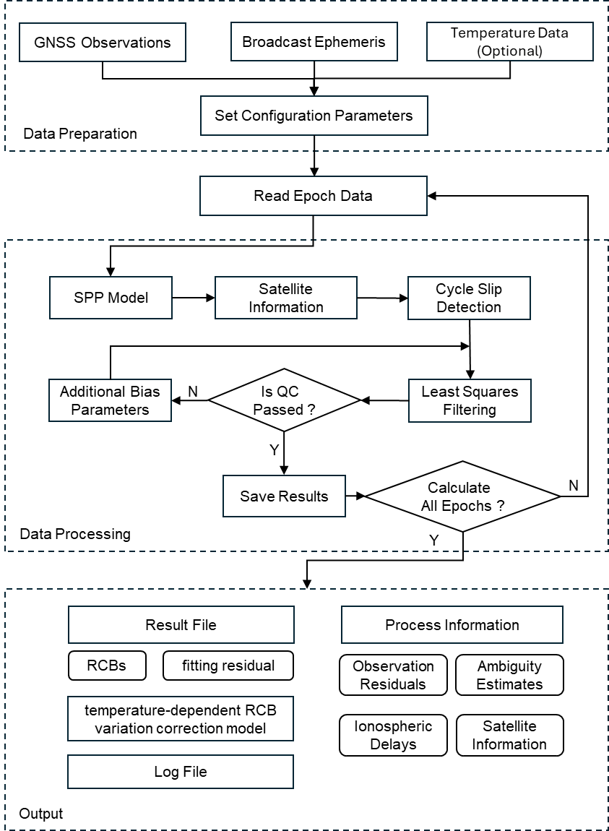
Fig. 1 The processing framework of TdRCB software

2.2 Processing strategies
For the processing strategies. The frequency-independent parameters, including the range, receiver clock offsets, satellite clock offsets, and tropospheric delays, were grouped into a single parameter and estimated as white noise. Ionospheric delays, ambiguities, and time-varying receiver code biases (RCBs) were also estimated. The detailed processing strategies are summarized in Table 1, and the complete mathematical derivations are provided in the Appendix for reference. Users can adjust the processing strategies according to their specific requirements.

Table 1 Processing strategies of TdRCB
Item | Processing strategies
Satellite constellation | GPS/GLONASS/BDS/Galileo/QZSS
Frequency number | Dual-frequency and above (up to 5 frequencies)
Functional mode | Uncombined model
Sampling rate | 30s
Cut-off mask angle | 10°
Observation weight | P = sin²(E) /σ2(σ2 indicates variance of code or carrier phase)  A priori precision of 0.003 and 0.3 m for raw phase and code
Filtering method | Least square filter
Frequency-independent parameters | Estimated as white noise
Ionospheric delays | Estimated as white noise
Phase ambiguities | Estimated as float constants for each satellite and frequency
SCB | Estimated as day constants for each satellite on the third or higher frequency band
RCB | Estimated as white noise
IFB | GLONASS, Estimated as white noise

Table 2 lists the frequency priority order implemented in the code.
Table 2 Frequency priorities for each system
GNSS Frequency | 1 | 2 | 3 | 4 | 5
GPS | P1 | P2 | P5 | \ | \
GLONASS | R1 | R2 | \ | \ | \
Galileo | E1 | E5a | E5b | E6 | E5
QZSS | P1 | P2 | P5 | \ | \
BDS-2 | B1I | B2I | B3I | \ | \
BDS-3 | B1I | B3I | B2b | B1C | B2a

3 Requirements

3.1 Supported platforms
TdRCB software was developed in the C/C++ language using the cross-platform CMAKE build system. It can be compiled and executed on both Windows and Linux operating systems. It is recommended to compile and debug TdRCB under Visual Studio 2022 in Windows or using GCC/Clang in Linux. Computer configuration requirements are as follows:
Operating system: Linux or Windows
System type: 32 or 64 bit
Memory: at least 512MB
Hard disk space: at least 500MB
CMAKE Version: CMAKE version higher than 3.10
Visual Studio Version: at least version 2022
The software has been tested under Windows 10 and Ubuntu 16.04 or higher, with all tests passed.

3.2 License
-------------------------------------------------------------------------------------------------
Copyright (C) 2026 by APM, CAS, All rights reserved.
-------------------------------------------------------------------------------------------------
This program is an open-source software: you can redistribute it and/or modify it under the terms of the GNU General Public License as published by the Free Software Foundation.

4 File structure
The project directory structure is as follows.
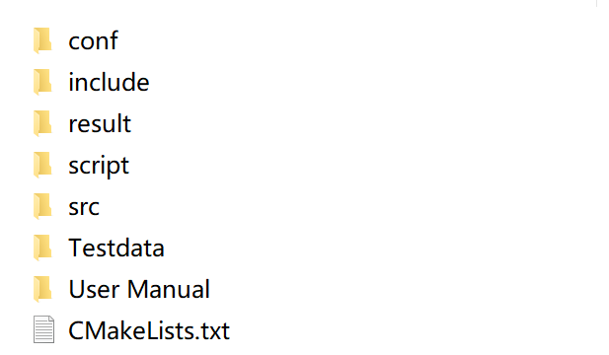
Fig. 2 File list
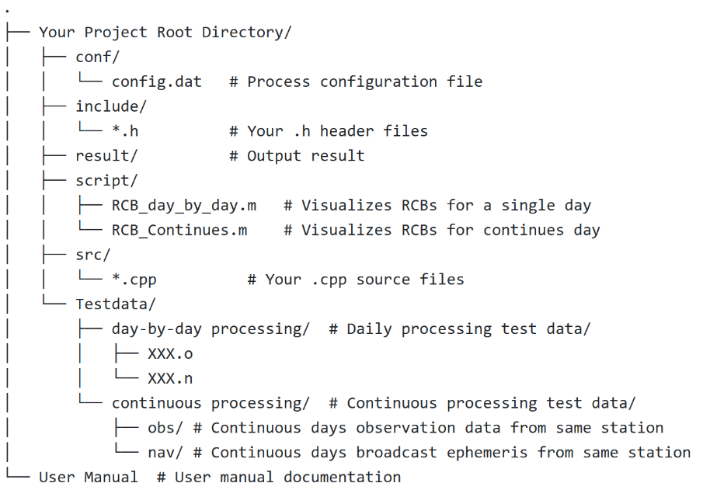
Fig. 3 The structure of File

5 Configuration File (config.dat)
The configuration file mainly contains four parts:
- Input file configuration
- Output file configuration
- Processing strategies configuration
- Station names

5.1 Input file configuration
Users should specify the input file paths in conf/config.dat. All paths are interpreted relative to the current working directory from which TDRCB is executed. Depending on the processing mode, users should configure either individual file paths or directory paths. The applicable parameters are controlled by Continue:
- Continue = 0 (daily processing): Use OBS_PATH and NAV_PATH.
- Continue = 1 (continuous/multi-day processing): Use OBS_DIR and NAV_DIR.
（1）OBS_PATH
Specifies the path to a single-station RINEX observation file. This parameter is used only when Continue=0.
（2）NAV_PATH
Specifies the path to the broadcast ephemeris file. This parameter is used only when Continue = 0.
（3）TEMP_PATH
Specifies the path to the temperature data file. This parameter is optional. If left empty, temperature-related processing is skipped, and the .tfit and .tres output files are not generated. The temperature data file must meet the following requirements:
- File format: CSV text file, with columns separated by commas or tabs.
- Column order: Year, month, day, hour, minute, second, and temperature.
- Temperature unit: Degrees Celsius (°C).
- Sampling interval: 30 s, covering a complete 24-hour period (2,880 epochs).
- Missing values: Missing temperature values can be left blank and will be interpolated by the software.
（4）OBS_DIR
Specifies the directory containing multi-day observation files. This parameter is used only when Continue = 1. The software scans this directory for observation files.
（5）NAV_DIR
Specifies the directory containing broadcast ephemeris files for multiple days. This parameter is used only when Continue = 1. The software scans this directory for broadcast ephemeris files.

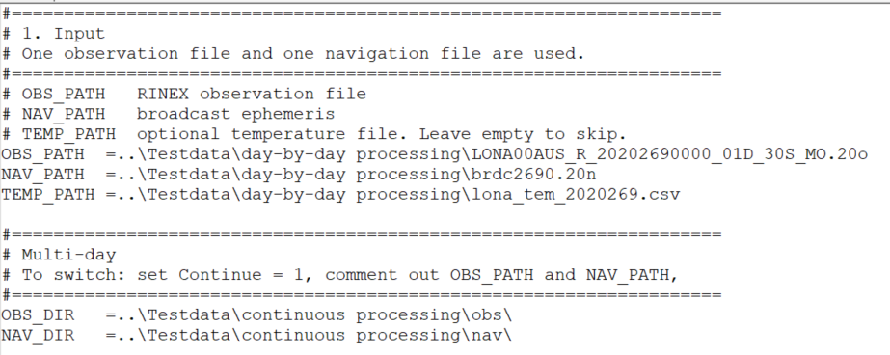
Fig. 4 Input file configuration

5.2 Output file configuration
Users should specify the output paths in conf/config.dat. All paths are interpreted relative to the current working directory from which TDRCB is executed.
（1）OUT_PRO
Specifies the directory for intermediate processing information. The output files use the .pro extension. The files contain information such as satellite positions, satellite clock offsets, ambiguities, elevation angles, and azimuth angles. For details, see Section 7.1.
（2）OUT_PATH
Specifies the directory for the main output files. The following three types of files are written to this directory:
Extension | Description
.out | Epoch-wise receiver code bias (RCB) estimates.
.tfit | Quadratic fitting model describing the relationship between temperature and RCB. Generated only when TEMP_PATH is configured.
.tres | Fitting residuals, calculated as the estimated RCB minus the model-predicted RCB. Generated only when TEMP_PATH is configured.
（3）OUT_LOG
Specifies the directory for log files, which use the .log extension. The log files record satellites excluded during processing and the corresponding reasons for exclusion, such as insufficient satellite elevation or an insufficient number of available frequency observations.
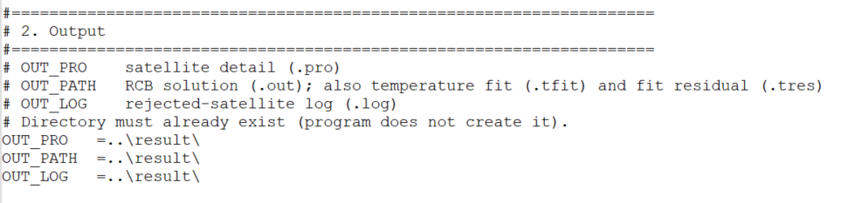
Fig. 5 Output file configuration

5.3 Processing strategies configuration
（1）UseBDS
Value | Description
0 | Use BDS-3 satellites only.
1 | Use BDS-2 satellites only.
2 | Use both BDS-2 and BDS-3 satellites. The first two frequencies are standardized as B1I and B3I for both systems.

（2）Frequency
Specifies the number of frequencies used in processing. For example, 2 indicates dual-frequency processing.
（3）Exclsats
Specifies the PRNs of satellites to be manually excluded from processing. Multiple satellite PRNs should be separated by spaces.

（4）System
Specifies the GNSS constellations included in the solution.
（5）Continue
Specifies the processing mode:
- 0: Daily processing.
- 1: Continuous or multi-day processing.
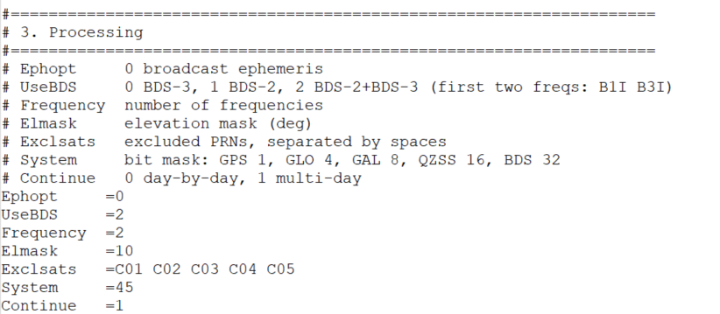
Fig. 6 Processing options 1 configuration

5.4 Station Information
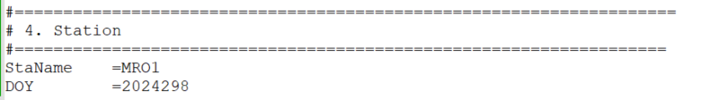
Fig. 7 Station information configuration

6 Compile and Run

6.1 Compile

6.1.1 Windows
Ensure that the complete compilation tool and CMAKE (version 3.10 or higher) is installed.
- Extract the files downloaded from GitHub
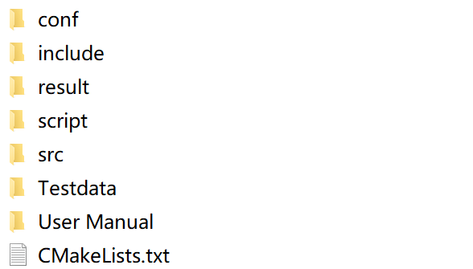
Fig. 8 The extracted files
- Search "x64 Native Tools Command Prompt for VS 2022"
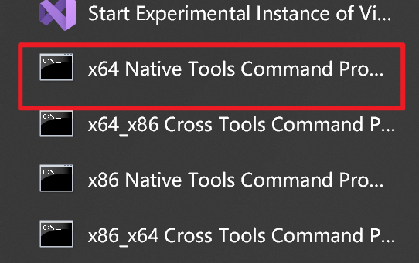
Fig. 9 Open Command Prompt
- Navigate to Project Directory and Compile. Execute these commands in sequence
① cd your_project_path ②mkdir build ③cmake -B build ④cmake --build build
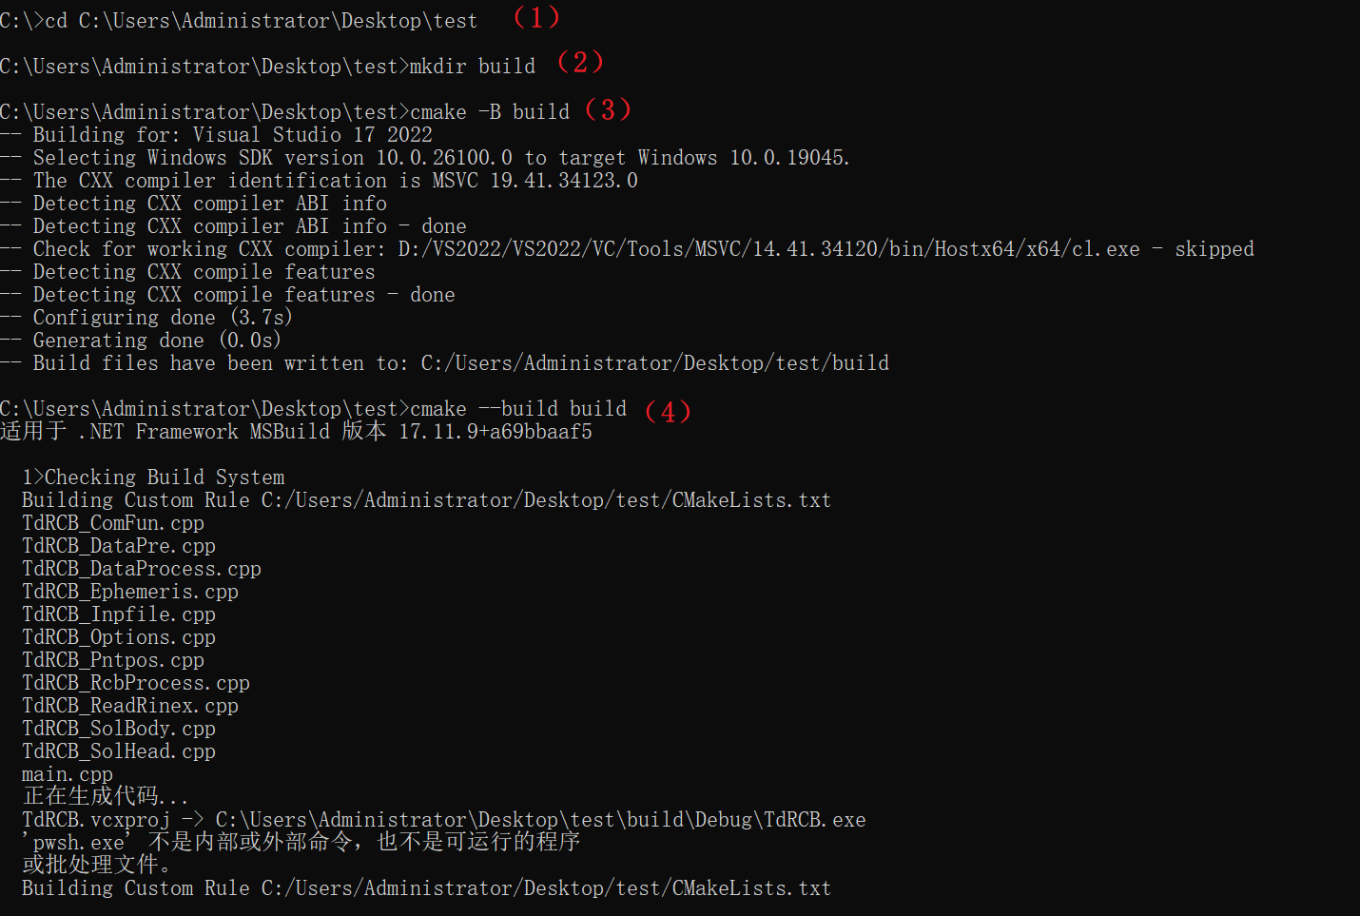
Fig. 10 Finish compile under Windows

Linux
Ensure that the complete compilation tool and CMAKE (version 3.10 or higher) is installed. Execute these commands in sequence: ① cd your_project_path ② mkdir build ③ cd build ④ cmake .. ⑤ make
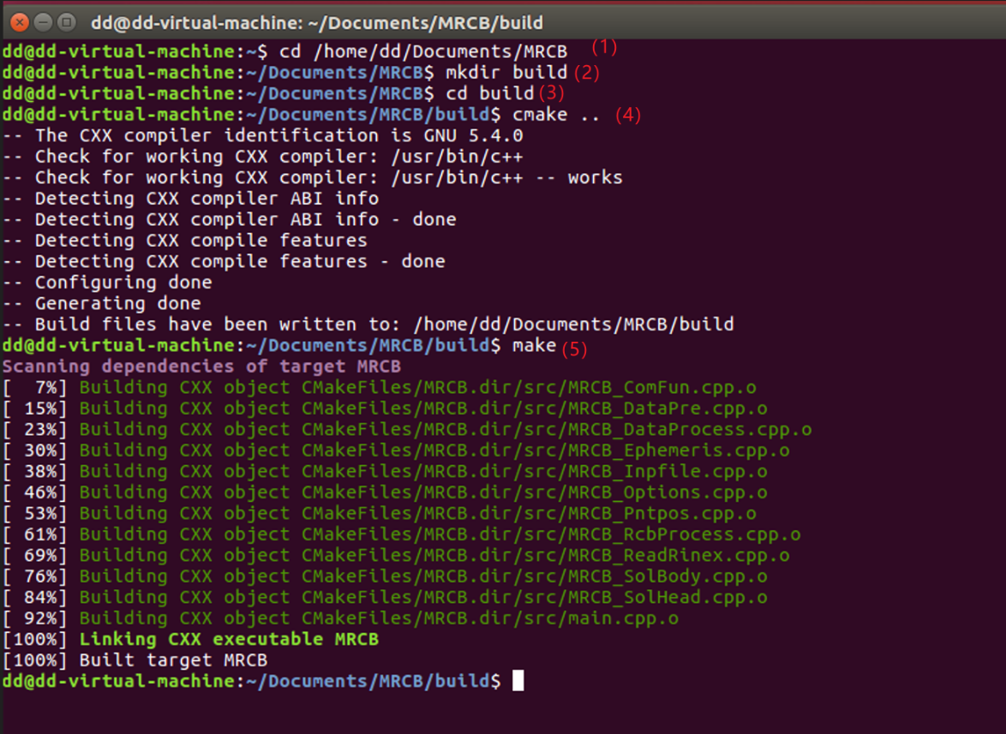
Fig. 11 Finish compile under Linux

6.2 Run
Using Windows as an example, we will introduce the operational process with two examples: the day-by-day process and continuous processing

6.2.1 day-by-day process
（1）Compile code
Reference the section 6.1.
（2）Data Preparation
In the config.dat file, configure the parameters by setting the input and output paths according to your specific needs and file locations.
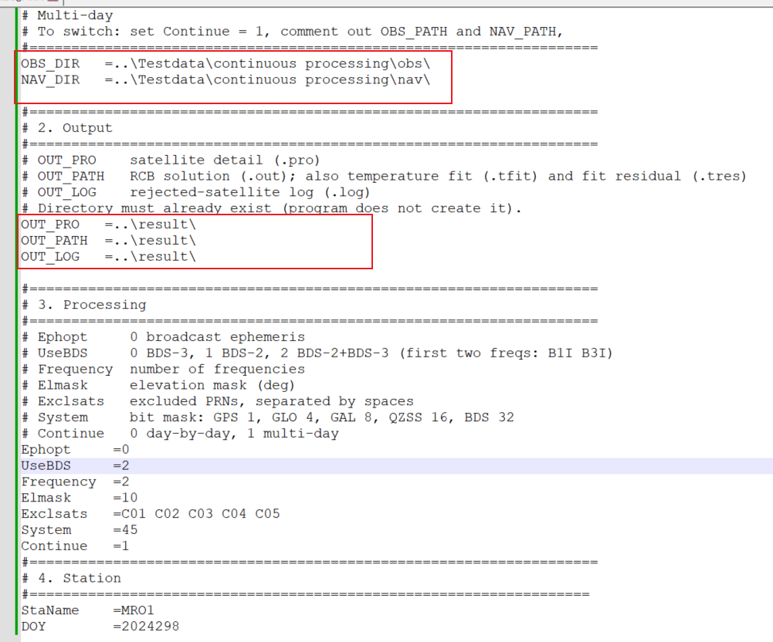
Fig. 12 Paths Requiring Configuration
（3）Run code
Recommend running in the command line: ① cd ./build/Debug ② TdRCB.exe
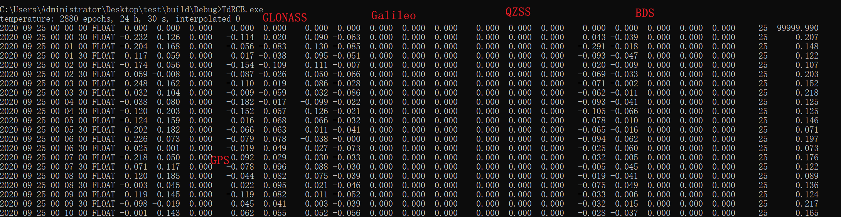
Fig. 13 Runtime Display
（4）Visualization
Two simple visualization scripts are located in the .\script directory and require MATLAB (version R2020b or higher) to run.
- RCB_day_by_day.m: Visualizes RCBs for a single day. Simply configure the file paths and specify the frequencies and systems to visualize.
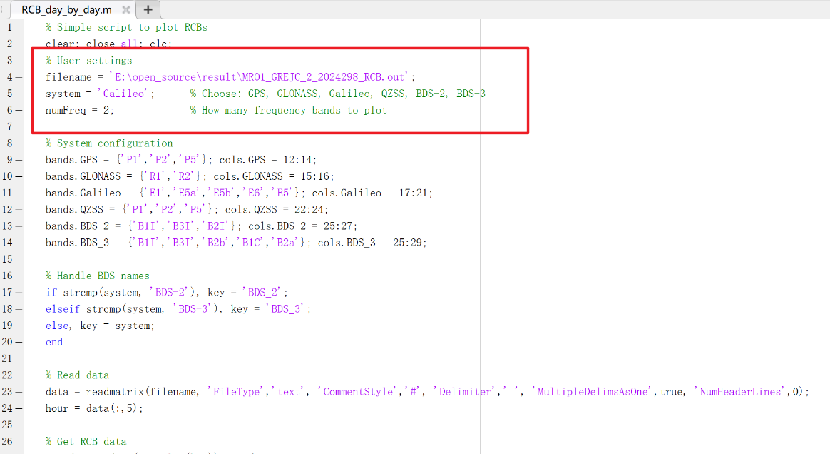
Fig. 14 Visualizes RCBs for a single day

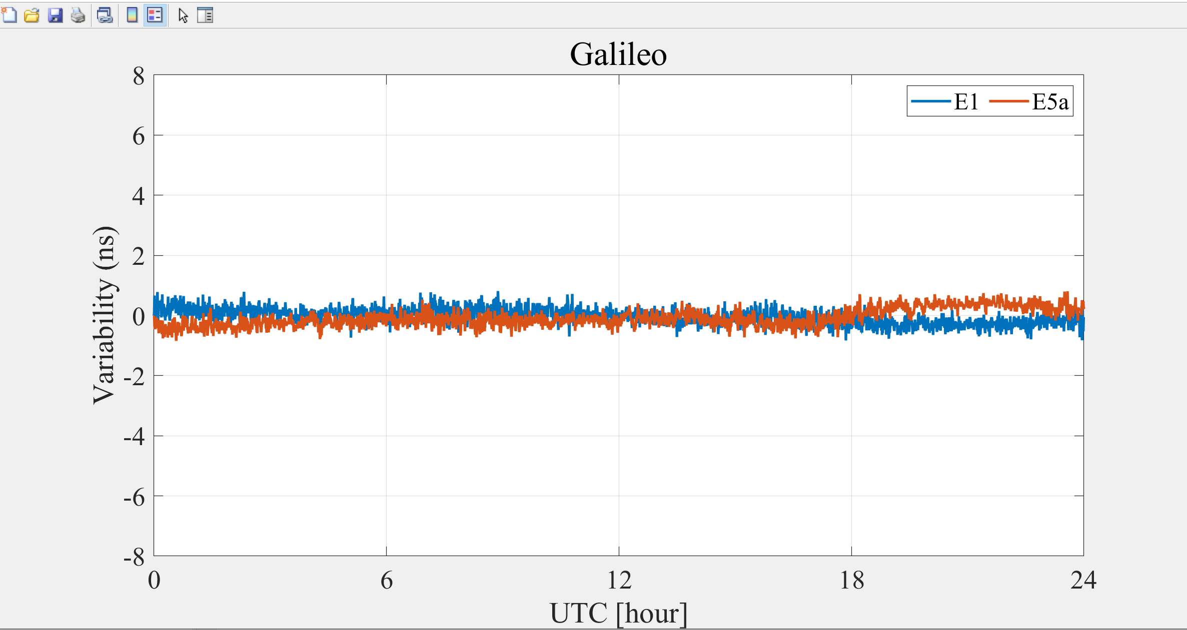
Fig. 15 Visualization Results

6.2.2 continuous processing
（1）Compile code
Reference the section 6.1.
（2）Data Preparation
In the config.dat file, configure the parameters by setting the input and output paths according to your specific needs and file locations. When use continuous processing, the following parameters do not need to be set and can be left as default: OBS_PATH, NAV_PATH, DOY. Configure the following input and output parameters:
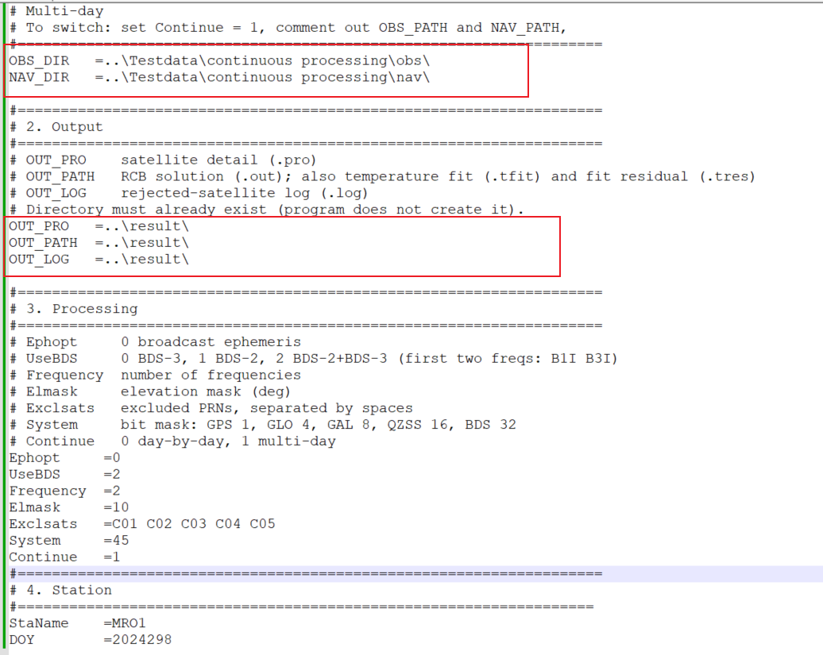
Fig. 16 Paths Requiring Configuration
（3）Run code
Recommend running in the command line.
（4）Visualization
- RCB_Continues.m: Visualizes RCBs for continues day. Simply configure the file paths and specify the frequencies and systems to visualize.
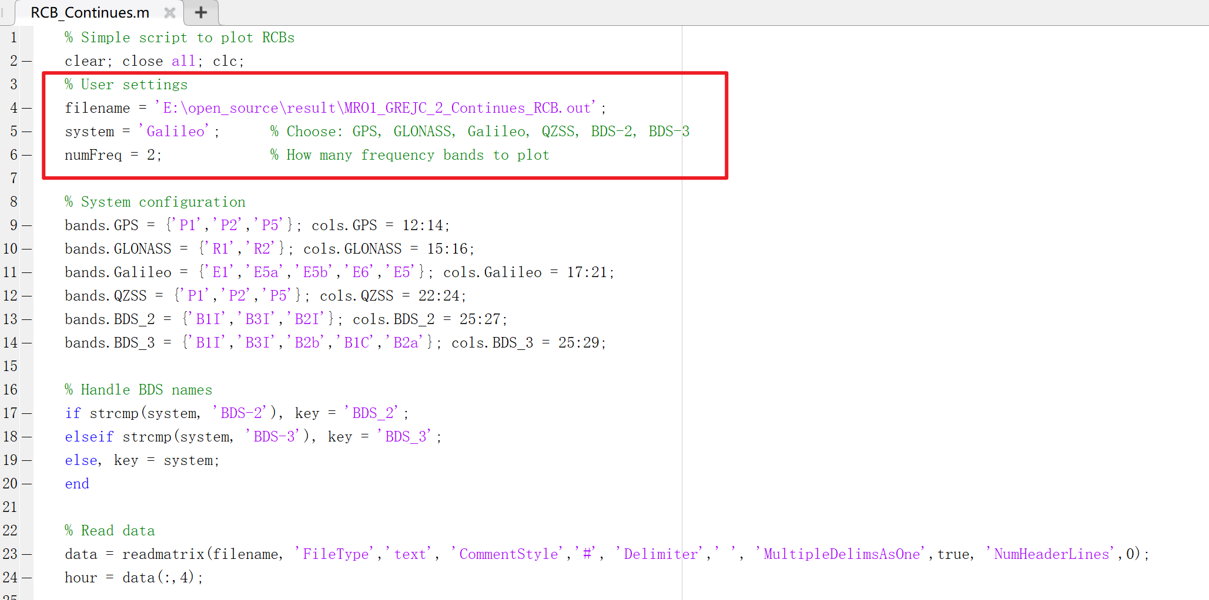
Fig. 17 Visualizes RCBs for continues day
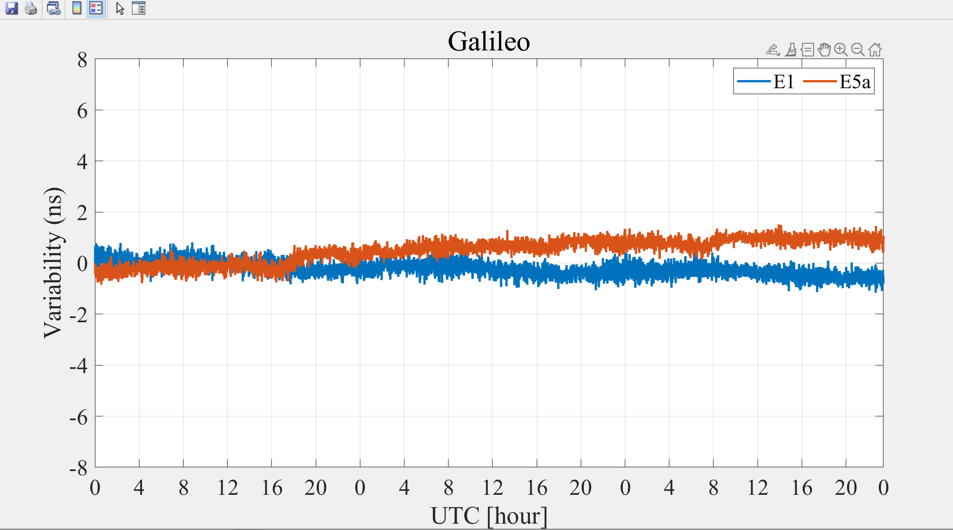
Fig. 18 Visualization Results

6.2.3 Linux Run
If you want run on the Linux system.
Execute these commands in sequence: ./TdRCB
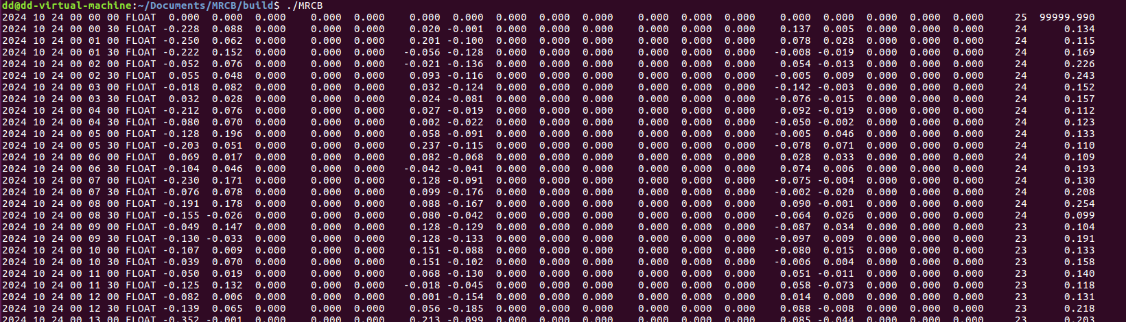
Fig. 19 Run on Linux

7 Output file format description

7.1 Result File
Name: XXXX_GEC_2_YYYYDOY_RCB.out
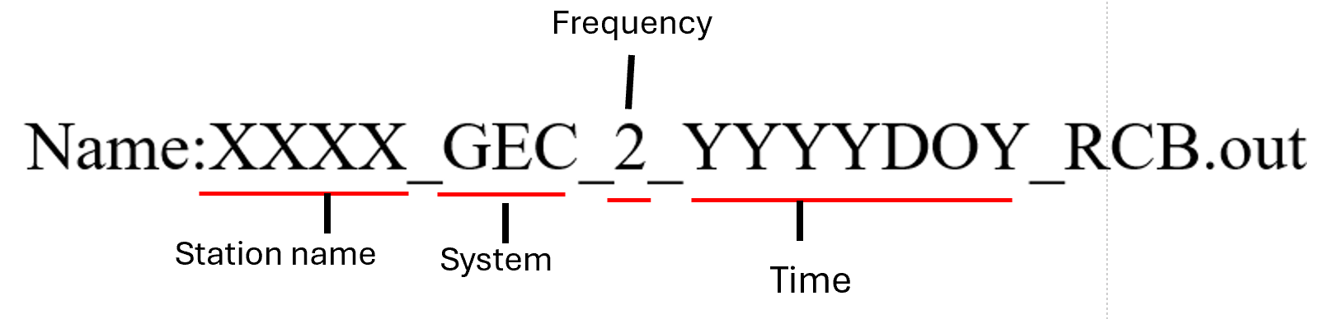
Fig. 20 Structure of output file name

Table 3 Result output file format description
Items |  | Value Type | Range
Epoch Time (GPST) | Year  Month  Day  Hour  Minute  Second | char  char  char  char  char  char | 1-4  6-7  9-10  12-13  15-16  18-22
Receiver Position (SPP) | X (m)  Y (m)  Z (m) | double  double  double | 25-37  41-52  55-67
Number of valid satellites |  | int | 71-72
GDOP |  | double | 76-81
GPS Time-varying RCB | P1  P2  P5 | double  double  double | 86-91  95-100  104-109
GLONASS Time-varying RCB | R1  R2 | double  double | 115-120  124-130
Galileo Time-varying RCB | E1  E5a  E5b  E6  E5 | double  double  double  double  double | 136-141  146-151  157-162  167-172  177-182
QZSS Time-varying RCB | P1  P2  P5 | double  double  double | 190-195  199-204  208-213
BDS-3 Time-varying RCB | B1I  B3I  B2b  B1C  B2a | double  double  double  double  double | 218-223  230-235  242-248  255-260  266-271
BDS-2 Time-varying RCB | B1I  B3I  B2I | double  double  double | 218-223  230-235  242-248

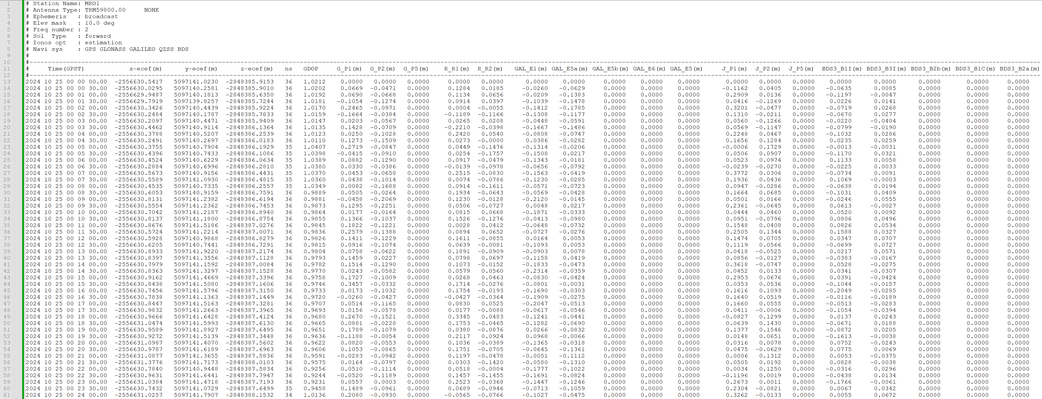
Fig. 21 Screenshot of RCBs result file

7.2 Process Information File
Name: XXXX_GEC_2_YYYYDOY_Inf.pro
Table 4 Process information file description
Items |  | Value Type | Range
Satellite Sys. & PRN |  | int | 1-4
Satellite Positions | X (m)  Y (m)  Z (m) | double  double  double | 6-13  23-35  38-51
Satellite Clock Offset | (m) | double | 56-67
Ion Delays | (m) | double | 75-83
Ambiguity | F1 (cycle)  F2 (cycle)  F3 (cycle)  F4 (cycle)  F5 (cycle) | double  double  double  double  double | 91-99  107-115  124-131  140-147  156-163
Satellite Elevation and Azimuth | Elevation (°)  Azimuth (°) | double  double | 173-179  188-195
post-fit carrier phase residuals | F1 (m)  F2 (m)  F3 (m)  F4 (m)  F5 (m) | double  double  double  double  double | 199-211  215-227  231-243  247-259  263-275
post-fit code residuals | F1 (m)  F2 (m)  F3 (m)  F4 (m)  F5 (m) | double  double  double  double  double | 280-292  296-308  312-324  328-340  344-356
SCB | F3 (m)  F4 (m)  F5 (m) | double  double  double | 365-372  381-388  397-404
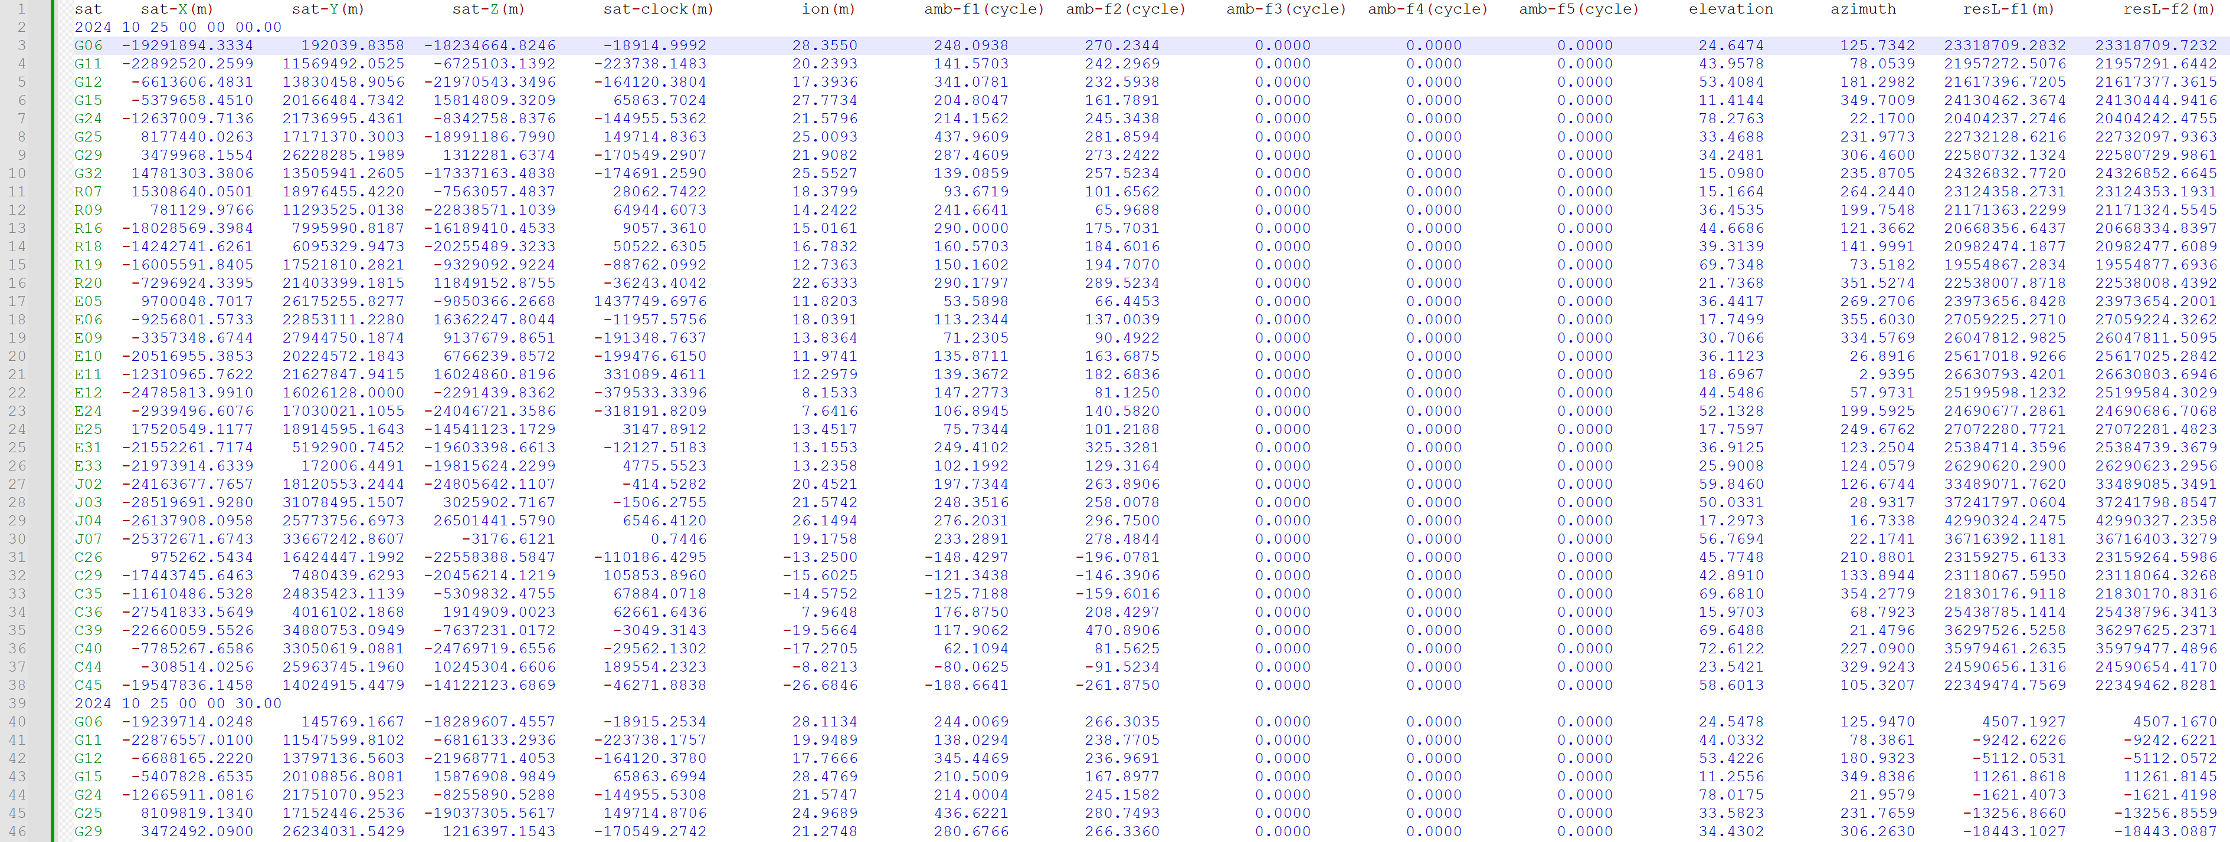
Fig. 22 Screenshot of Process Information file

7.3 Log file
Name: XXXX_GEC_2_YYYYDOY_Sat.log
The log file mainly contains the record of satellite eliminations.
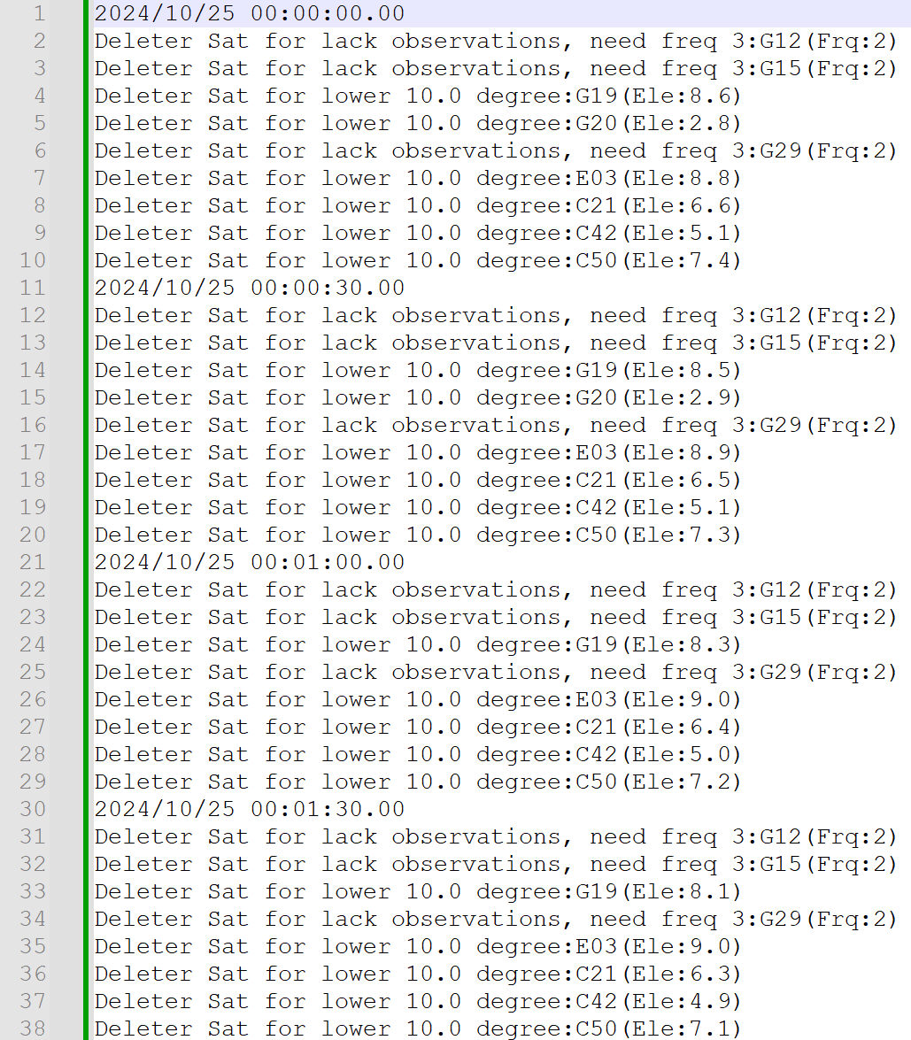
Fig. 23 Screenshot of Log file

7.4 tfit File
This file provides the quadratic fitting models relating temperature (T) (°C) to receiver code bias (RCB) (m) for each GNSS constellation and frequency.
Field | Description
System | GNSS constellation: GPS, GLONASS, Galileo, QZSS, or BDS.
Band | Frequency identifier, such as G_P1 or BDS_B1I.
N | Number of epochs included in the fitting process.
a | Quadratic coefficient（m/℃²）
b | Linear coefficient（m/℃）
c | Constant term（m）
R2 | Coefficient of determination R², indicating the goodness of fit.
Equation | $RCB(T)=aT^{2}+bT+c$

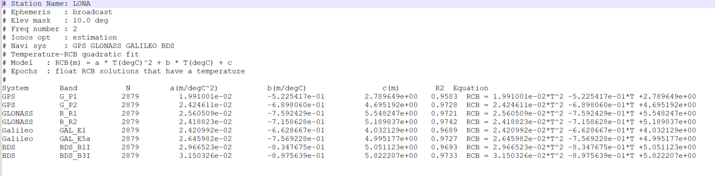
Fig. 24 Screenshot of .tfit file

7.5 tres File
This file contains the fitting residuals at each epoch.
Residual definition: $residual={RCB}_{solved}-{RCB}_{model}$
Units: RCB, RCBfit, and residual are expressed in meters (m), while temperature is expressed in degrees Celsius (°C).

Field | Description
Time(GPST) | Epoch time in GPS Time (GPST), represented by year, month, day, hour, minute, and second.
System | GNSS constellation name.
Band | Frequency identifier.
T(degC) | Temperature at the corresponding epoch (°C).
RCB(m) | Estimated receiver code bias at the corresponding epoch (m).
RCBfit(m) | RCB predicted by the fitted temperature model (m).
residual(m) | Fitting residual, calculated as the estimated RCB minus the model-predicted RCB (m).

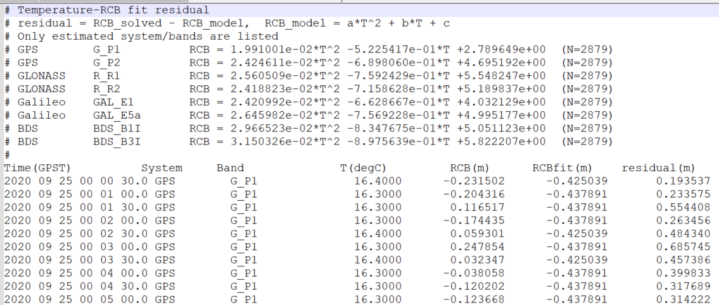
Fig. 25 Screenshot of . tres file

7.6 Execution Interface
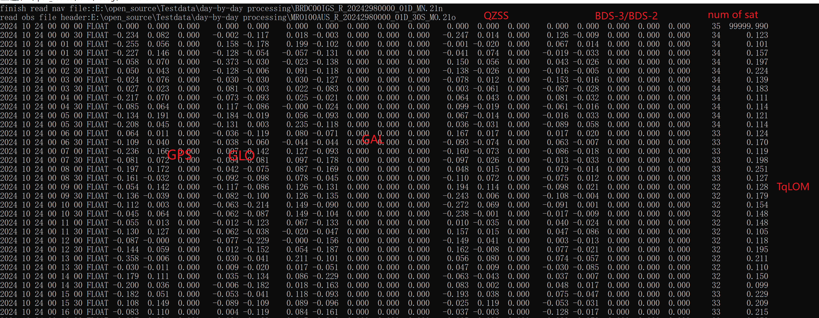
Fig. 27 Runtime Display RCBs

Appendix
(1) CDMA RCB Function Model
We commence with the undifferenced and uncombined GNSS observation equations, which are written as (Teunissen and Montenbruck, 2017)
$$\begin{aligned}\left\{\begin{aligned}&{E[P}_{r,f}^{s}(i)]=ρ_{r}^{s}(i)+μ_{f}⋅I_{r,1}^{s}(i)+b_{r,f}-b_{f}^{s} \\ &{E[L}_{r,f}^{s}(i)]=ρ_{r}^{s}(i)-μ_{f}⋅I_{r,1}^{s}(i)+λ_{f}α_{r,f}^{s}\end{aligned}\right.\#\left(1\right)\end{aligned}$$
where $E(.)$denotes the expectation operator. $P_{r,f}^{s}$ and $L_{r,f}^{s}$ represent observed-minus-calculated code and phase observations of a satellite $s$ tracked by a receiver $r$ on the frequency $f$ at the epoch $i$, respectively. The frequency-independent parameters in this, including the range, receiver clock offsets, satellite clock offsets, and tropospheric delays, were combined into a single parameter $ρ_{r}^{s}(i)$. the first-order slant ionospheric delay $I_{r,1}^{s}(i)$ on the first frequency linked to other frequencies by the coefficient $μ_{f}=λ_{f}^{2}/λ_{1}^{2}$ with $λ_{f}$ being the wavelength, the RCB $b_{r,f}$and its satellite counterpart $b_{f}^{s}$, and the float ambiguity $α_{r,f}^{s}=N_{r,f}^{s}+δ_{r,f}-δ_{f}^{s}$ containing the receiver phase bias (RPB) $δ_{r,f}$, the satellite phase bias $δ_{f}^{s}$, and the integer ambiguity $N_{r,f}^{s}$. We consider the parameters with an epoch index $i$ as time-varying quantities and assume the parameters without the epoch index to be time constant.
Departing from the time-constant assumption of the RCB, we consider it a time-varying parameter and rewrite Eq. (1) as
$$\begin{aligned}\left\{\begin{aligned}&{E[P}_{r,f}^{s}(i)]=ρ_{r}^{s}(i)+μ_{f}⋅I_{r,1}^{s}(i)+b_{r,f}(1)+{\tilde{b}}_{r,f}(i)-b_{f}^{s} \\ &{E[L}_{r,f}^{s}(i)]=ρ_{r}^{s}(i)-μ_{f}⋅I_{r,1}^{s}(i)+λ_{f}α_{r,f}^{s}\end{aligned}\right.\#\left(2\right)\end{aligned}$$
where
$$\begin{aligned}{\tilde{b}}_{r,f}\left(i\right)=b_{r,f}\left(i\right)-b_{r,f}\left(1\right)\#\left(3\right)\end{aligned}$$
denotes the time-differenced receiver bias between epoch $i$ and the first epoch, but parameters in Eq. (2) are not uniquely estimable due to the rank deficient problem. For this issue, we turn to the S-system theory (Baarda, 1973; Teunissen, 1985), which constraints a minimum set of parameters and formulates a full-rank model estimating the linear functionals of the original parameters. To make it clear, we first decompose the receiver and satellite code biases on the first two frequencies as
$$\begin{aligned}{\left(.\right)}_{r,f}={\left(.\right)}_{r,IF}+{μ_{f}\left(.\right)}_{r,GF}\#\left(4\right)\end{aligned}$$
where the geometry-free combination of a frequency-dependent quantity is defined as
$$\begin{aligned}{\left(.\right)}_{GF}=\frac{1}{μ_{2}-μ_{1}}\left[{\left(.\right)}_{2}-{\left(.\right)}_{1}\right]\#\left(5\right)\end{aligned}$$
Inserting Eq. (4) into the code observations equation in Eq. (2) yields
$$\begin{aligned}\left\{\begin{aligned}&{E[P}_{r,f}^{s}(i)]=ρ_{r}^{s}(i)+μ_{f}I_{r,1}^{s}(i)+b_{r,IF}(1)+{μ_{f}b}_{r,IF}(1)-μ_{f}b_{r,GF}^{s}+{\tilde{b}}_{r,f}(i)+{\overline{b}}_{r,f>2}^{s} \\ &{E[L}_{r,f}^{s}(i)]=ρ_{r}^{s}(i)-μ_{f}I_{r,1}^{s}(i)+λ_{f}α_{r,f}^{s}\end{aligned}\right.\#\left(6\right)\end{aligned}$$
where
$${\overline{b}}_{r,f>2}^{s}=[b_{r,f}(1)-b_{r,IF}(1)-u_{f}⋅b_{r,GF}(1)]-(b_{,f}^{s}-u_{f}⋅b_{,GF}^{s})$$
denotes the combination of receiver and satellite code biases on the third frequency and above.The rank deficiency elimination for Eq. (6) becomes straightforward, as we can lump the parameters that have common coefficients:
$$\begin{aligned}{E[P}_{r,f}^{s}(i)]={\overline{ρ}}_{r}^{s}(i)+μ_{f}{\overline{I}}_{r,1}^{s}(i)+{\tilde{b}}_{r,f}(i)+{\overline{b}}_{r,f>2}^{s}\#\left(7\right)\end{aligned}$$
where
$$\begin{aligned}\left\{\begin{aligned}&{\overline{ρ}}_{r}^{s}(i)=ρ_{r}^{s}(i)+b_{r,IF}(1) \\ &{\overline{I}}_{r,1}^{s}(i)=I_{r,1}^{s}(i)+b_{r,GF}(1)-b_{,GF}^{s}\end{aligned}\right.\#\left(8\right)\end{aligned}$$
denote the frequency-independent parameter and ionospheric delays, respectively. When dealing with the phase observations in Eq. (2), we first replace${ ρ}_{r}^{s}(i)$ and $I_{r,1}^{s}(i)$ with ${\overline{ρ}}_{r}^{s}(i)$ and ${\overline{I}}_{r,1}^{s}(i)$, resulting in additional code biases. By lumping these biases with ambiguities, we obtain the full-rank observation equations as
$$\begin{aligned}\left\{\begin{aligned}&{E[P}_{r,f}^{s}(i)]={\overline{ρ}}_{r}^{s}(i)+μ_{f}{\overline{I}}_{r,1}^{s}(i)+{\tilde{b}}_{r,f}(i)+{\overline{b}}_{r,f>2}^{s} \\ &{E[L}_{r,f}^{s}(i)]={\overline{ρ}}_{r}^{s}(i)-μ_{f}{\overline{I}}_{r,1}^{s}(i)+λ_{f}{\overline{α}}_{r,f}^{s}\end{aligned}\right.\#\left(9\right)\end{aligned}$$
where
$$\begin{aligned}{\overline{α}}_{r,f}^{s}=α_{r,f}^{s}+\left[b_{,IF}^{s}-b_{r,IF}\left(1\right)\right]/λ_{f}-μ_{f}⋅\left[b_{,GF}^{s}-b_{r,GF}\left(1\right)\right]/λ_{f}\#\left(10\right)\end{aligned}$$
denote the estimable parameters contain the RCB at the first epoch.
(2) FDMA RCB Function Model
GLONASS raw code and carrier phase observation equations as (Teunissen, 2019)
$$\begin{aligned}\left\{\begin{aligned}&{E[P}_{r,f}^{s}(i)]=ρ_{r}^{s}(i)+μ_{f}^{s}⋅I_{r,1}^{s}(i)+b_{r,f}-b_{f}^{s}+k^{s}Δb_{r,f} \\ &{E[L}_{r,f}^{s}(i)]=ρ_{r}^{s}(i)-μ_{f}^{s}⋅I_{r,1}^{s}(i)+λ_{f}^{s}(α_{r,f}^{s}+k^{s}Δδ_{r,f})\end{aligned}\right.\#\left(11\right)\end{aligned}$$
different from CDMA observation equations, there exist receiver code and phase biases that are linear functions of the satellite frequency channel number, $Δb_{r,f}$and $Δδ_{r,f}$, respectively. The meanings of the remaining parameters are the same as in Eq. (1).
In particular, GLONASS satellites have different wavelengths, expressed as $λ_{f}^{s}$. Furthermore, the coefficients of the ionospheric parameters $μ_{f}^{s}$ are also satellite-dependent. To simplify the coefficients of the ionospheric parameters, they are defined based on the frequency of each GLONASS R1 and R2 satellite as follows:
$$\begin{aligned}F_{f}^{s}=F_{f}^{0}+k^{s}ΔF_{f}\#\left(12\right)\end{aligned}$$
where $F_{f}^{0}$ is the center frequency, $ΔF_{f}$ is the frequency offset, $ΔF_{1}=9/16$, $ΔF_{2}=7/16$, $k^{s}$is the frequency channel number of satellite $s$, and they satisfy $|k^{s}|≤13$, $ΔF_{1}/F_{1}^{0}=1/2848$, $ΔF_{2}/F_{2}^{0}=1/2848$. Therefore, the wavelength $λ_{f}^{s}$ can be expressed as:
$$\begin{aligned}λ_{f}^{s}=\frac{c}{F_{f}^{0}+k^{s}ΔF_{f}}=\frac{λ_{f}^{0}}{1+\frac{k^{s}ΔF_{f}}{F_{f}^{0}}}=\frac{2848λ_{f}^{0}}{2848+k^{s}}\#\left(13\right)\end{aligned}$$
where$λ_{f}^{0}=c/F_{f}^{0}$is the wavelength corresponding to the center frequency. According to Equation (13), the coefficients of the ionospheric parameters can be written as:
$$\begin{aligned}μ_{f}^{s}={\left(\frac{λ_{f}^{s}}{λ_{1}^{s}}\right)}^{2}={\left(\frac{2848λ_{f}^{0}}{2848+k^{s}}∙\frac{2848+k^{s}}{2848λ_{1}^{0}}\right)}^{2}=μ_{f}\#\left(14\right)\end{aligned}$$
Therefore, Equation (11) can be simplified as:
$$\begin{aligned}\left\{\begin{aligned}&{E[P}_{r,f}^{s}(i)]=ρ_{r}^{s}(i)+μ_{f}⋅I_{r,1}^{s}(i)+b_{r,f}-b_{f}^{s}+k^{s}Δb_{r,f} \\ &{E[L}_{r,f}^{s}(i)]=ρ_{r}^{s}(i)-μ_{f}⋅I_{r,1}^{s}(i)+λ_{f}^{s}(α_{r,f}^{s}+k^{s}Δδ_{r,f})\end{aligned}\right.\#\left(15\right)\end{aligned}$$
Departing from the time-constant assumption of the RCB, we consider it a time-varying parameter and rewrite Eq. (14) as:
$$\begin{aligned}\left\{\begin{aligned}&{E[P}_{r,f}^{s}(i)]=ρ_{r}^{s}(i)+μ_{f}⋅I_{r,1}^{s}(i)+b_{r,f}(1)+{\tilde{b}}_{r,f}\left(i\right)-b_{f}^{s}+k^{s}Δb_{r,f}(1)+k^{s}Δ{\overline{b}}_{r,f}(i) \\ &{E[L}_{r,f}^{s}(i)]=ρ_{r}^{s}(i)-μ_{f}⋅I_{r,1}^{s}(i)+λ_{f}^{s}(α_{r,f}^{s}+k^{s}Δδ_{r,f})\end{aligned}\right.\#\left(16\right)\end{aligned}$$
where
$$\begin{aligned}\left\{\begin{aligned}&{\tilde{b}}_{r,f}\left(i\right)=b_{r,f}\left(i\right)-b_{r,f}\left(1\right) \\ &Δ{\overline{b}}_{r,f}(i)=Δb_{r,f}(i)-Δb_{r,f}(1)\end{aligned}\right.\#\left(17\right)\end{aligned}$$
Note that, apart from the IFBs, the structure of the GLONASS equations is entirely consistent with that of CDMA systems. Therefore, following the rank deficiency elimination procedure used for CDMA, the following equations are obtained:
$$\begin{aligned}\left\{\begin{aligned}&{E[P}_{r,f}^{s}(i)]={\overline{ρ}}_{r}^{s}(i)+μ_{f}{\overline{I}}_{r,1}^{s}(i)+{\tilde{b}}_{r,f}\left(i\right)+k^{s}Δ{\overline{b}}_{r,f}(i) \\ &{E[L}_{r,f}^{s}(i)]={\overline{ρ}}_{r}^{s}(i)-μ_{f}{\overline{I}}_{r,1}^{s}(i)+λ_{f}^{s}({\overline{α}}_{r,f}^{s}+k^{s}Δδ_{r,f})\end{aligned}\right.\#\left(18\right)\end{aligned}$$
where
$$\begin{aligned}\left\{\begin{aligned}&{\overline{ρ}}_{r}^{s}(i)=ρ_{r}^{s}(i)+b_{r,IF}(1)-b_{,IF}^{s}+k^{s}Δb_{r,IF}(1) \\ &{\tilde{I}}_{r,1}^{s}(i)=I_{r,1}^{s}(i)+b_{r,GF}(1)-b_{,GF}^{s}+k^{s}Δb_{r,GF}(1) \\ &{\overline{α}}_{r,f}^{s}=α_{r,f}^{s}+k^{s}Δδ_{r,f}+\frac{\left[b_{,IF}^{s}-b_{r,IF}\left(1\right)-k^{s}Δb_{r,IF}\left(1\right)\right]}{λ_{f}^{s}}-\frac{μ_{f}⋅\left[b_{,GF}^{s}-b_{r,GF}\left(1\right)-k^{s}Δb_{r,GF}\left(1\right)\right]}{λ_{f}^{s}}\end{aligned}\right.\#\end{aligned}$$

Acknowledgement
We sincerely thank Mr. Tomoji Takasu, the author of RTKLIB software. His great work and open-source spirit help many researchers. Our software is built on the software framework of RTKLIB, and we are grateful to the whole RTKLIB community.

References
- Teunissen P. J. G., Montenbruck O (eds) (2017) Springer handbook of global navigation satellite systems. Springer International Publishing, Cham
- Baarda W (1973) S-transformations and criterion matrices. Netherlands Geodetic Commission
- Teunissen P. J. G. (1985) Zero order design: generalized inverses, adjustment, the datum problem and S-transformations. In: Optimization and design of geodetic networks. Springer Berlin Heidelberg, Berlin, Heidelberg, pp 11–55
- Teunissen, P. J. G. (2019). A new glonass fdma model. GPS solutions, 23(4), 100.

